**Reset a User Password**

When a user creates a GSI Cost Tool account, they can set their own password. The password is stored in the database in such a way that it cannot be read, or reset directly

But user with 'superuser' (administrative) can reset the user's password from the 'GSI Cost Tool Admin Page'.

When a superuser logs into the GSI Cost Tool, the menu in the upper right corner of the screen has 3 options. Use the first option to open the 'GSI Cost Tool Admin Page'

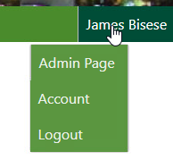

On the GSI Cost Tool Admin Page the superuser can add, edit, and delete data. The superuser can select any option by selecting the name of the option, or the 'Change' menu button.

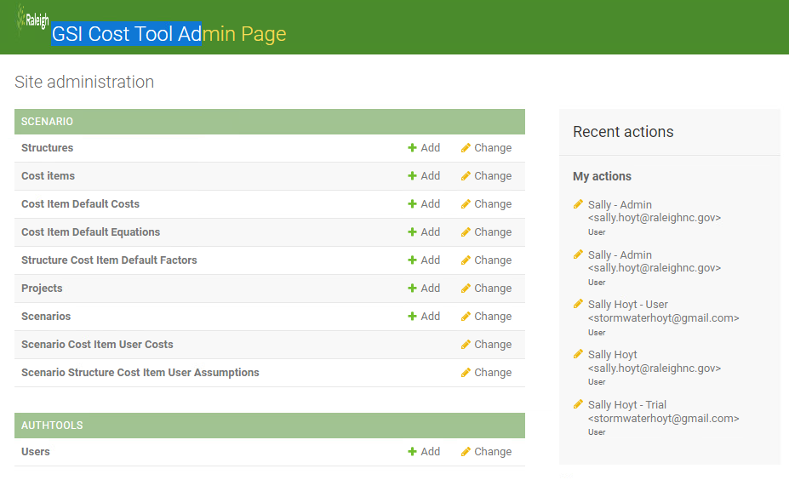

To reset the users password, select the AUTHTOOLS **Users** from the menu of options. In this image, the example account we want to change is 'James Bisese'. Find the user you want to make active and click their NAME. This will open the editor screen

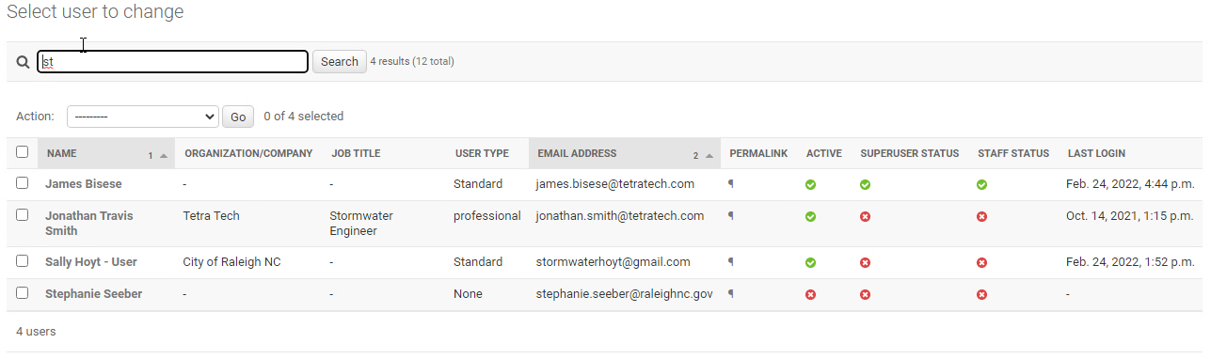

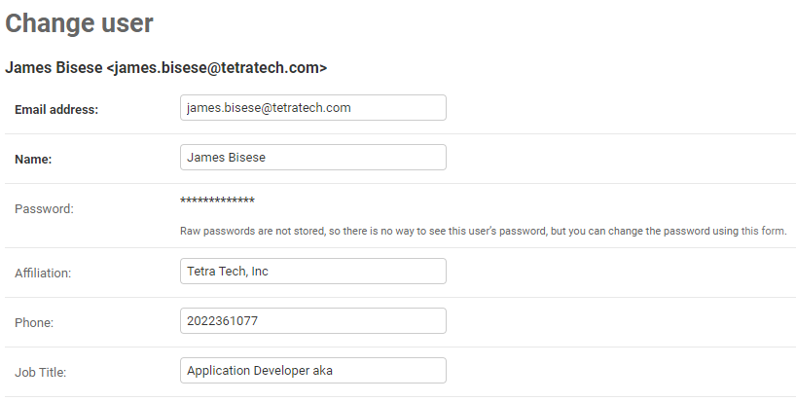

**NOTE: This is a work around to a bug. You should be able click the link to the 'Reset Password' page using the hyperlink on the sentence '**Raw passwords are not stored, so there is no way to see this user’s password, but you can change the password using [this form](http://127.0.0.1:94/admin/authtools/user/6/change/%7B%7D).'**, but something is not correct, so you need to do the following.**

**When you are on the Change user page, go to your browser URL bar, and edit the URL. Replace the work 'change' with 'password'. This will open the 'Change password' page.**

[**https://gsicosttool.raleighnc.gov/admin/authtools/user/34/change**](https://gsicosttool.raleighnc.gov/admin/authtools/user/34/change)

**edit to**

**https://gsicosttool.raleighnc.gov/admin/authtools/user/34/password**

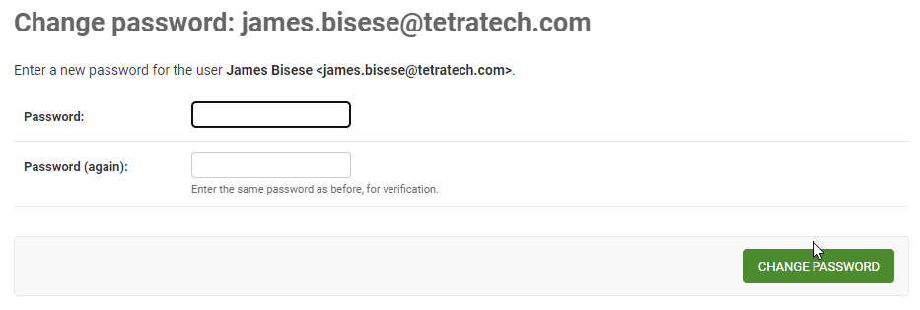

Enter a new password for the user. Click the 'CHANGE PASSWORD' button to save the change.